**Day 5 - Testing, Error Handling, and Backend Integration Refinement**

**Overview**

My website is built with **Next.js and Tailwind CSS**, ensuring a **fully responsive** design that adapts smoothly to all screen sizes. Functional testing covers **navigation, forms, responsiveness, API data handling**, and **data sanity**. The data is **properly fetched and accurately displayed**. Any issues found during testing were documented and fixed.

### ****Responsive Design****

My website is **fully responsive**, ensuring it adapts seamlessly to different screen sizes, from desktops to mobile devices, providing an optimal user experience across all platforms. 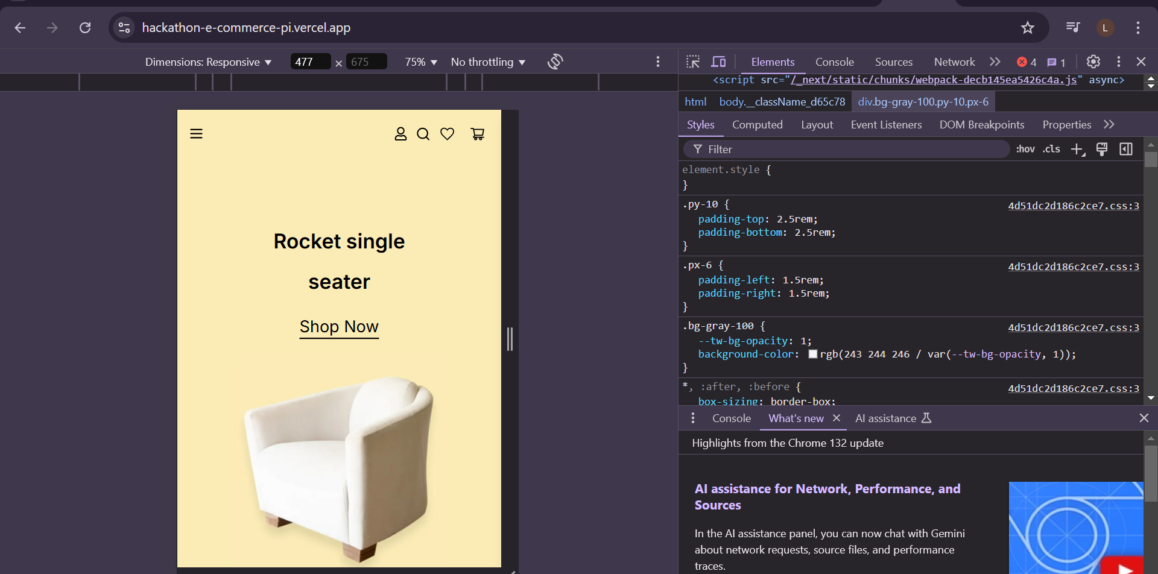

### ****API Functionality****

The **API is fully functional**, ensuring smooth data fetching and accurate display of information across the website. All API calls are working as expected, providing real-time data updates without any issues.

### ****Error Handling – API****

### The **API is working properly**. This error is being investigated, and the image will be properly fetched and displayed once the

issue is resolved. 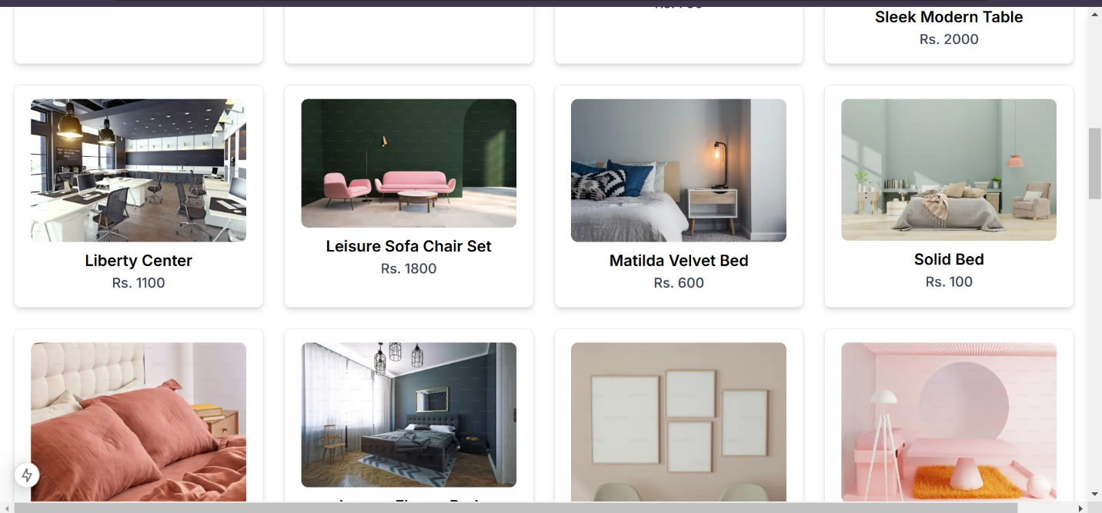

### ****Functional Testing – Add to Cart Page****

The **Add to Cart** functionality is currently **in progress**, and I am actively working on its implementation. The main focus is to ensure that items are **added, updated, and removed** correctly in the cart while maintaining **data accuracy**. Functional testing will cover **button actions, quantity updates, price calculations, and persistence** across sessions. My goal is to make the website fully functional as soon as possible.

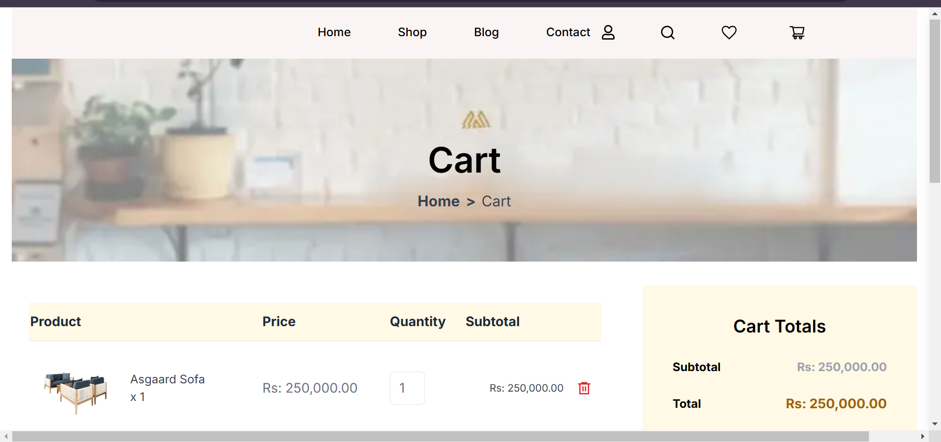

### C:\Users\ESHOP\Pictures\cp.png

### ****Functional Testing – My Account Login Page****

The **Login functionality** works **smoothly**, with focus on **correct username and password handling**. Testing includes ensuring the **"remember me"** feature works properly, allowing users to securely access their accounts. The rest of the functionality is still **in progress**.

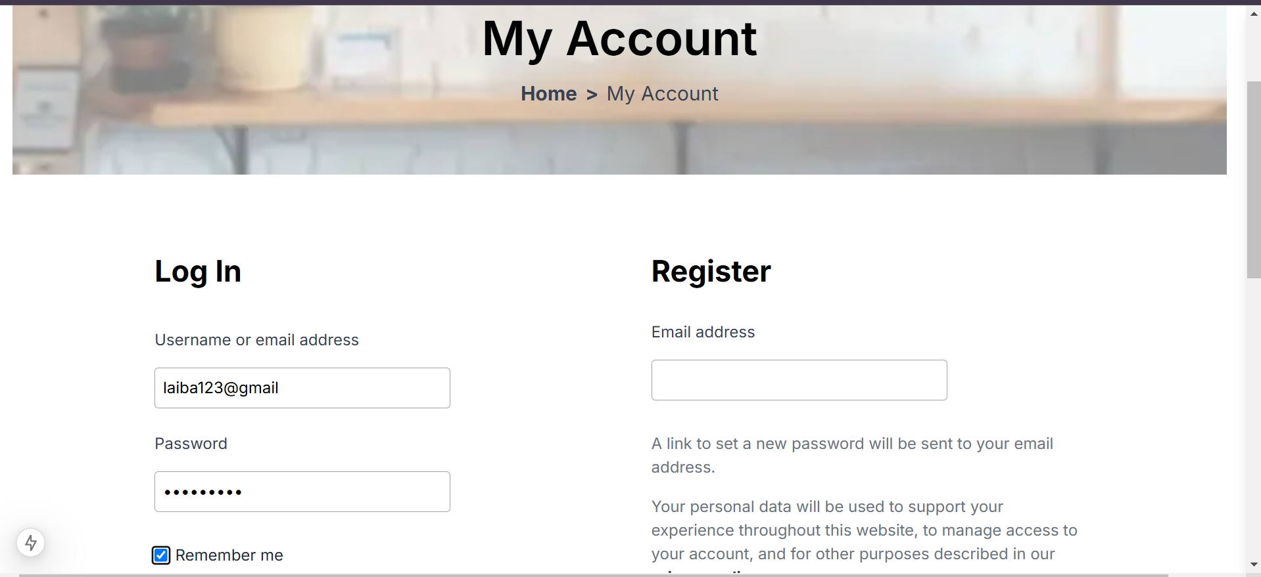

### ****Functional Testing – Checkout Page****

The **Checkout** functionality is currently **in progress**, focusing on **order processing, payment handling, and data accuracy**. Testing ensures that transactions are smooth, prices are correctly calculated, and user details are securely processed. 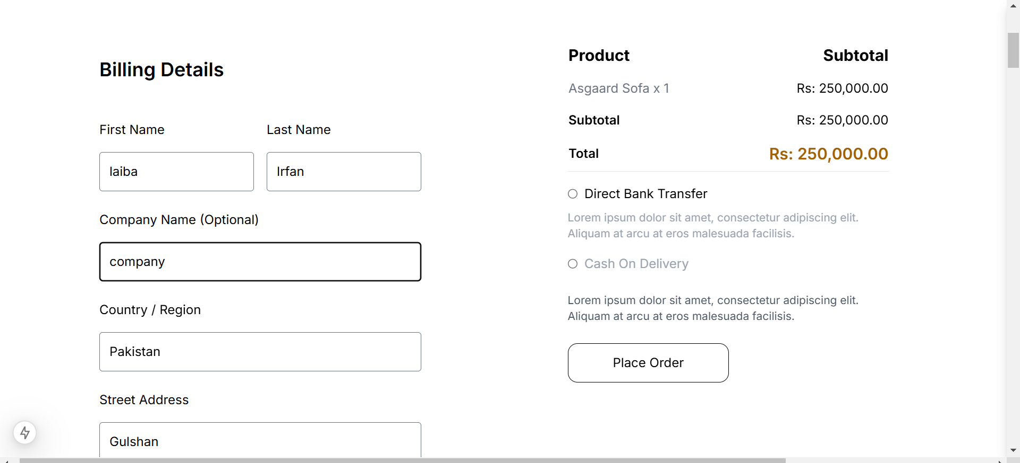

### ****Successfully Installed Thunder Client****

Thunder Client has been successfully installed and is ready for use. You can now use it to make API requests, including testing the Sanity API for creating or updating your product documents.

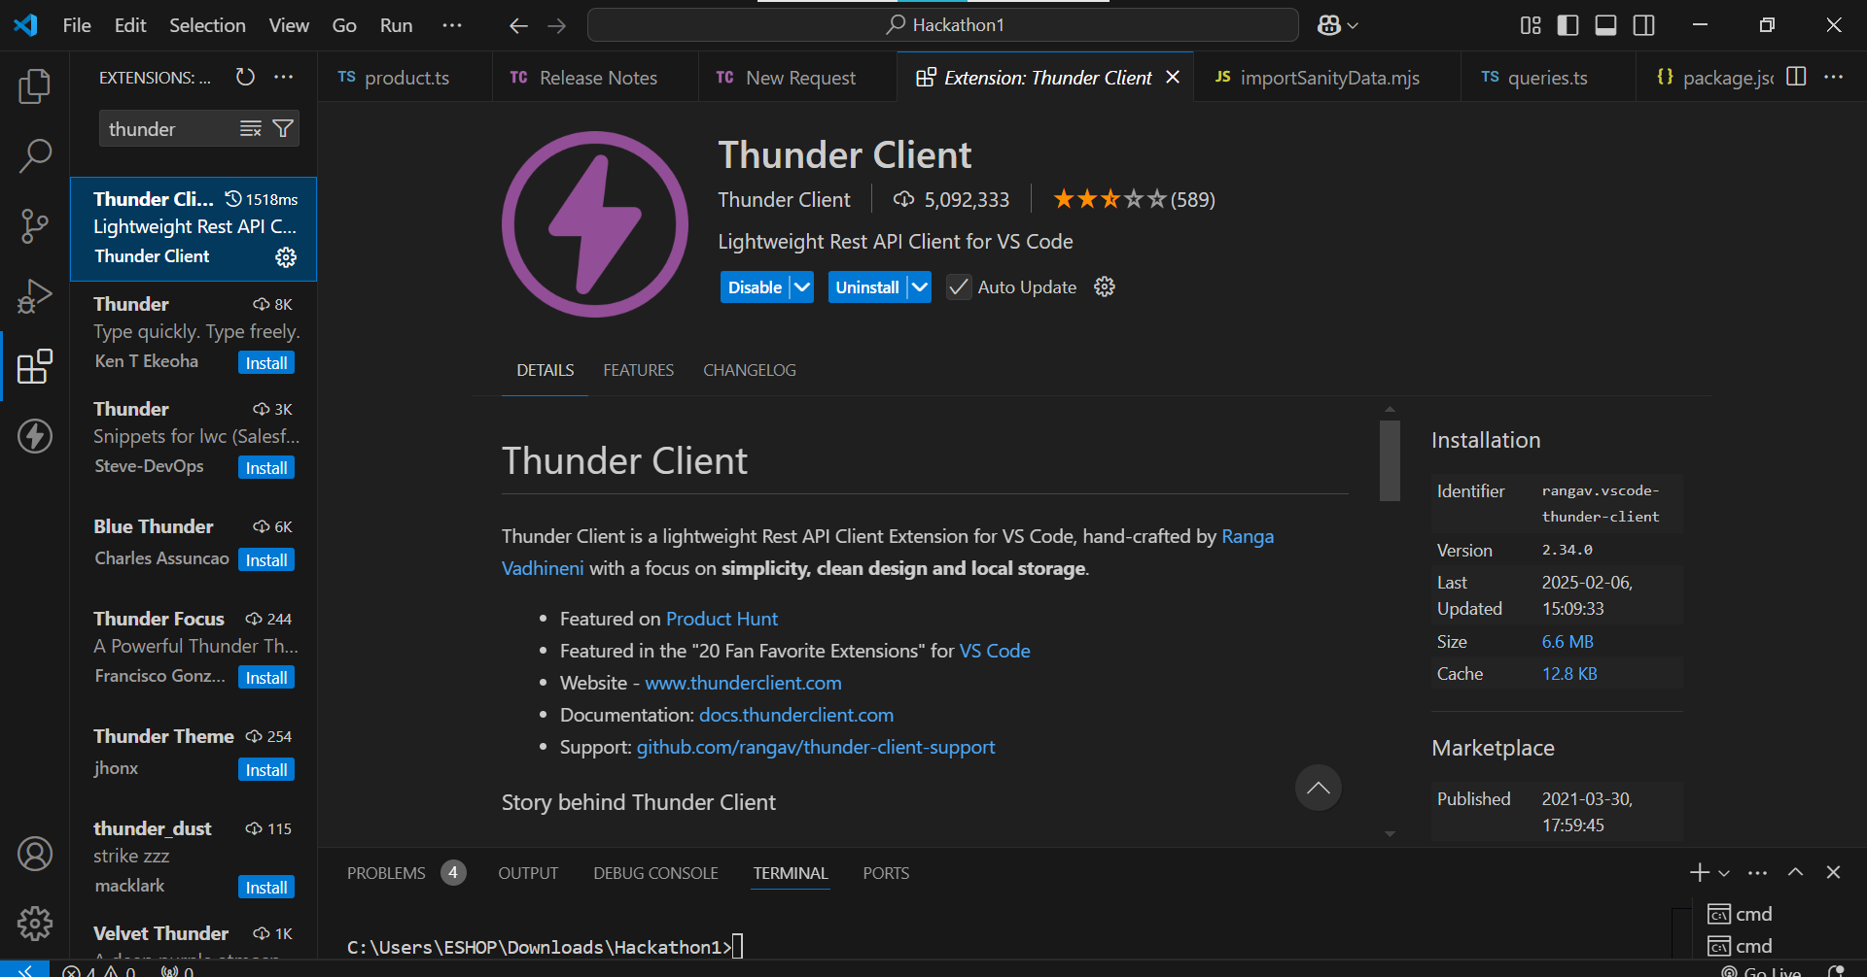

**Status**

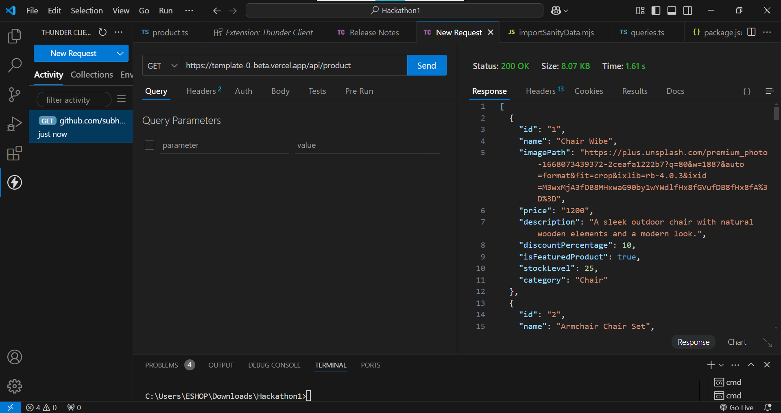

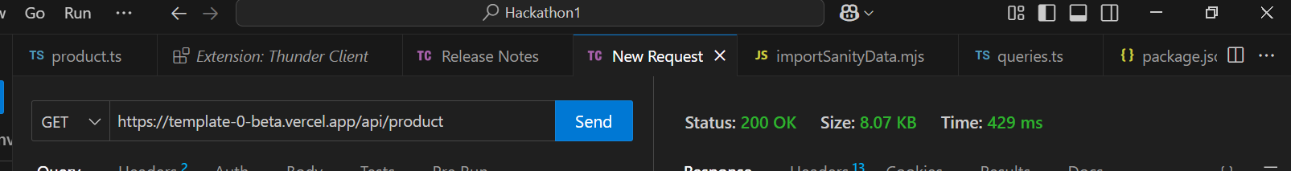

### ****CSV Report****

|  |  |  |  |  |  |  |  |  |
| --- | --- | --- | --- | --- | --- | --- | --- | --- |
| **Test Case ID** | **Test Case Description** | **Test Steps** | **Expected Result** | **Actual Result** | **Status** | **Severity Level** | **Assigned To** | **Remarks** |
| 2 | TC001 | Validate product listing page | Open product page > Verify products | Products displayed correctly | Products displayed correctly | Passed | high | - | No issues found |
| 3 | TC002 | Test API error handling | Disconnect API > Refresh page | Show fallback UI with error message | Error message shown | Passed | Medium | - | Handled gracefully |
| 4 | TC003 | Check cart functionality | Add product to cart > Verify cart contents | Cart updates with added product | Cart updates as expected | Passed | High | - | Functionality under development. |
| 5 | TC004 | Ensure responsiveness on mobile | Resize browser window > Check layout | Layout adjusts properly to screen size | Responsive layout working as intended | Passed | Medium | - | Test successful |

**Performance Optimization Using Lighthouse**

To analyze and optimize the performance of your web application, you can use **Lighthouse**, a powerful tool provided by Google. It helps identify issues related to performance, accessibility,

lighthouse http://localhost:3000 --view

SEO, and best practices. 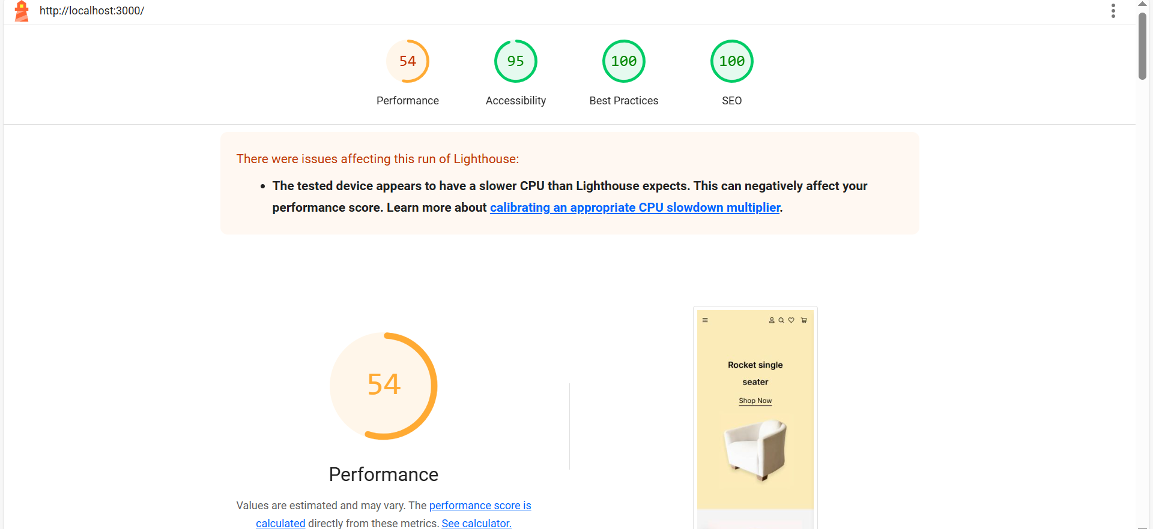

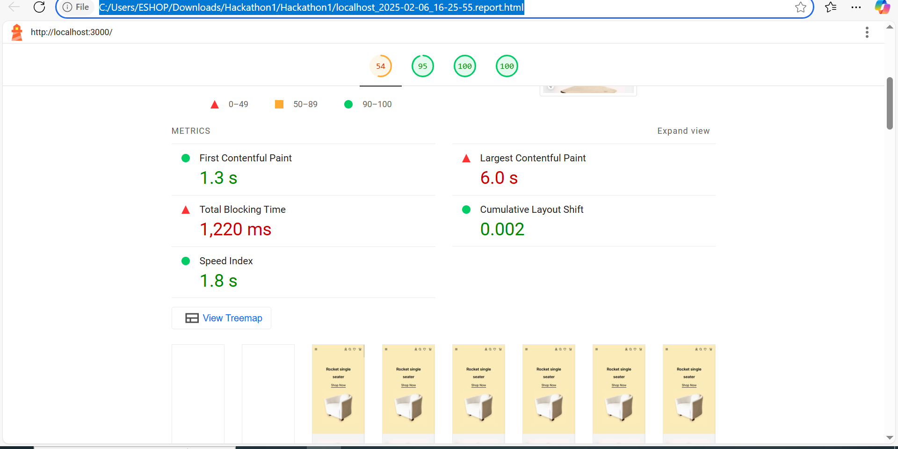

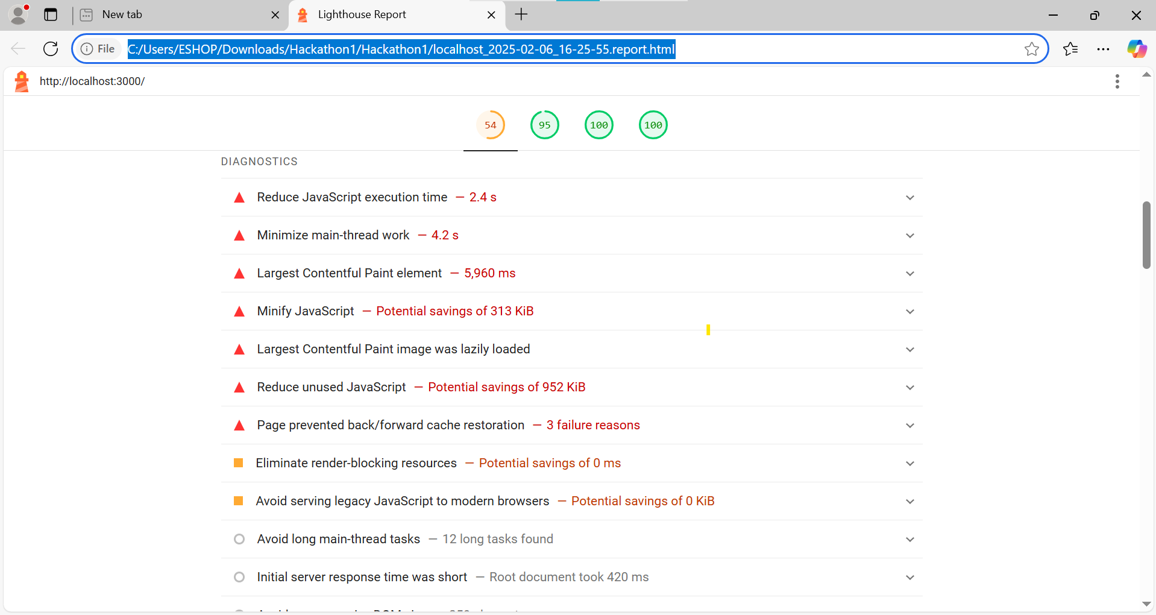

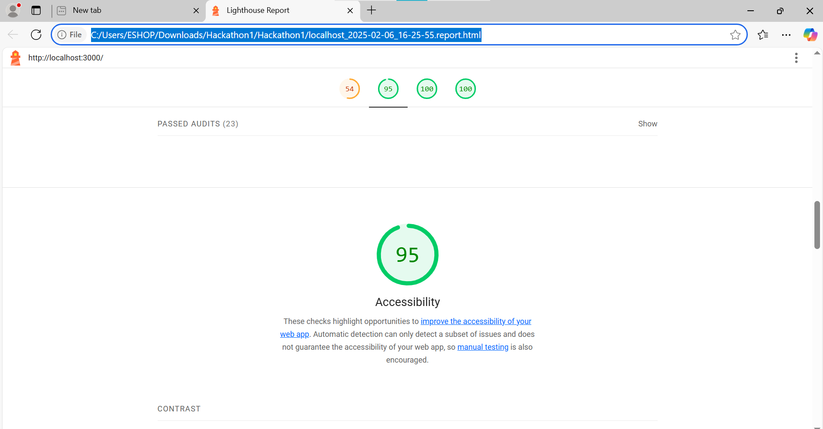

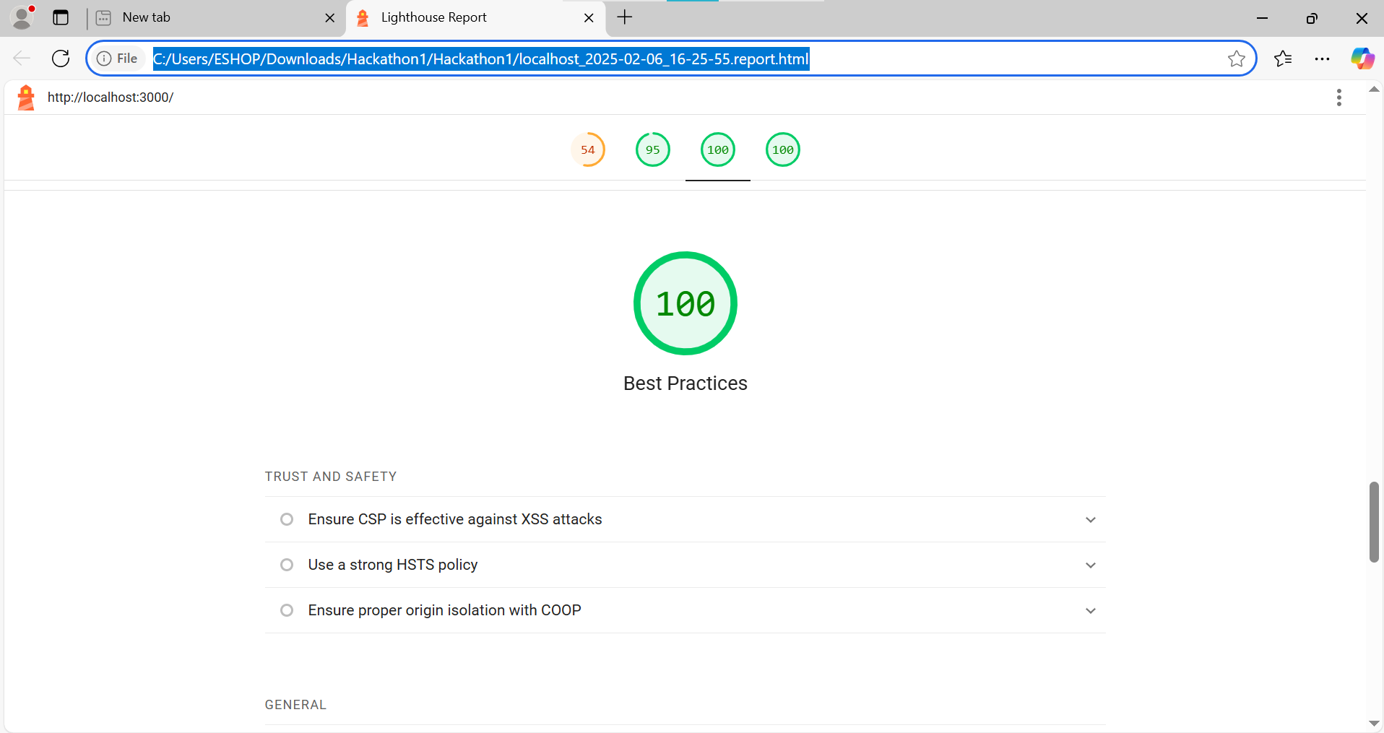

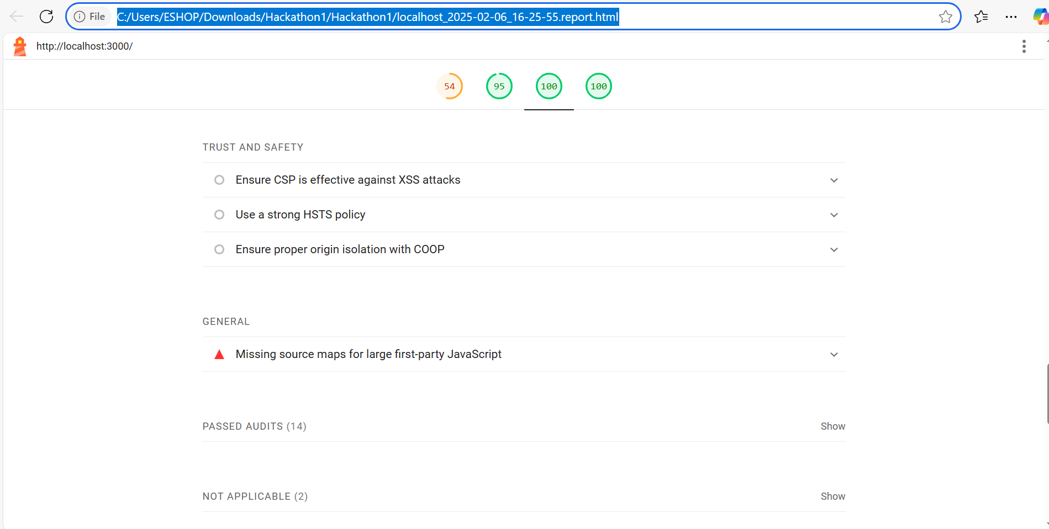

Trust and Safety

Ensure CSP is effective against XSS attacks

|  |  |  |
| --- | --- | --- |
|  |  |  |

Use a strong HSTS policy

|  |  |  |
| --- | --- | --- |
|  |  |  |

Ensure proper origin isolation with COOP

|  |  |  |
| --- | --- | --- |
|  |  |  |

General

Missing source maps for large first-party JavaScript

|  |  |  |  |  |  |  |  |  |
| --- | --- | --- | --- | --- | --- | --- | --- | --- |
| Passed audits (14)  Show   |  |  |  |  | | --- | --- | --- | --- | |  |  |  |  |   Not applicable (2)  Show  100  SEO  These checks ensure that your page is following basic search engine optimization advice. There are many additional factors Lighthouse does not score here that may affect your search ranking, including performance on [Core Web Vitals](https://web.dev/explore/vitals?utm_source=lighthouse&utm_medium=cli). [Learn more about Google Search Essentials](https://support.google.com/webmasters/answer/35769).  Additional items to manually check (1)  Hide  Structured data is valid  Run these additional validators on your site to check additional SEO best practices.  Passed audits (8)  Show  Not applicable (2)  Show   * Captured at Feb 6, 2025, 4:25 PM GMT+5 * Emulated Moto G Power with Lighthouse 12.3.0 * Single page session * Initial page load * Slow 4G throttling * Using Chromium 132.0.0.0 with cli   Generated by **Lighthouse** 12.3.0 | [File an issue](https://github.com/GoogleChrome/Lighthouse/issues) |

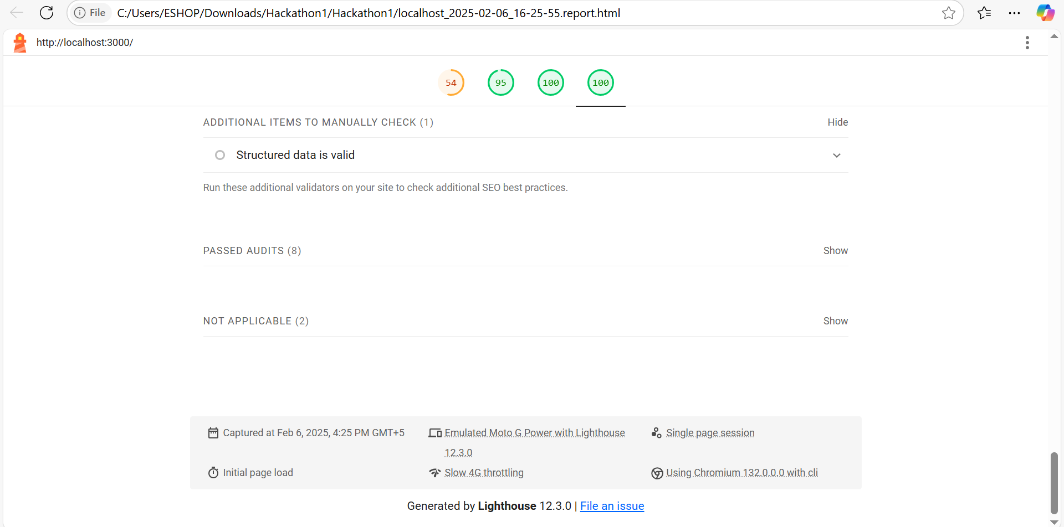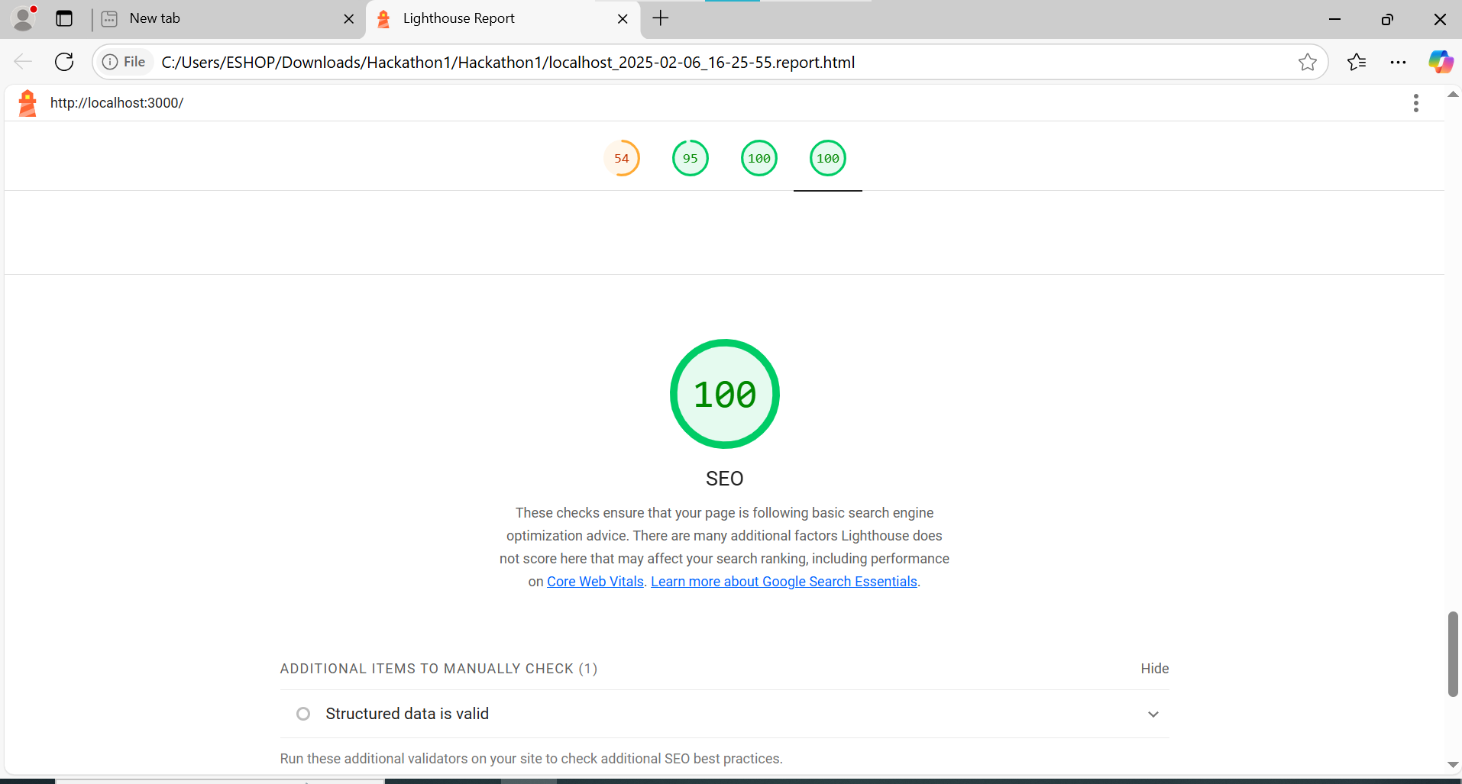

**Developer Resources**

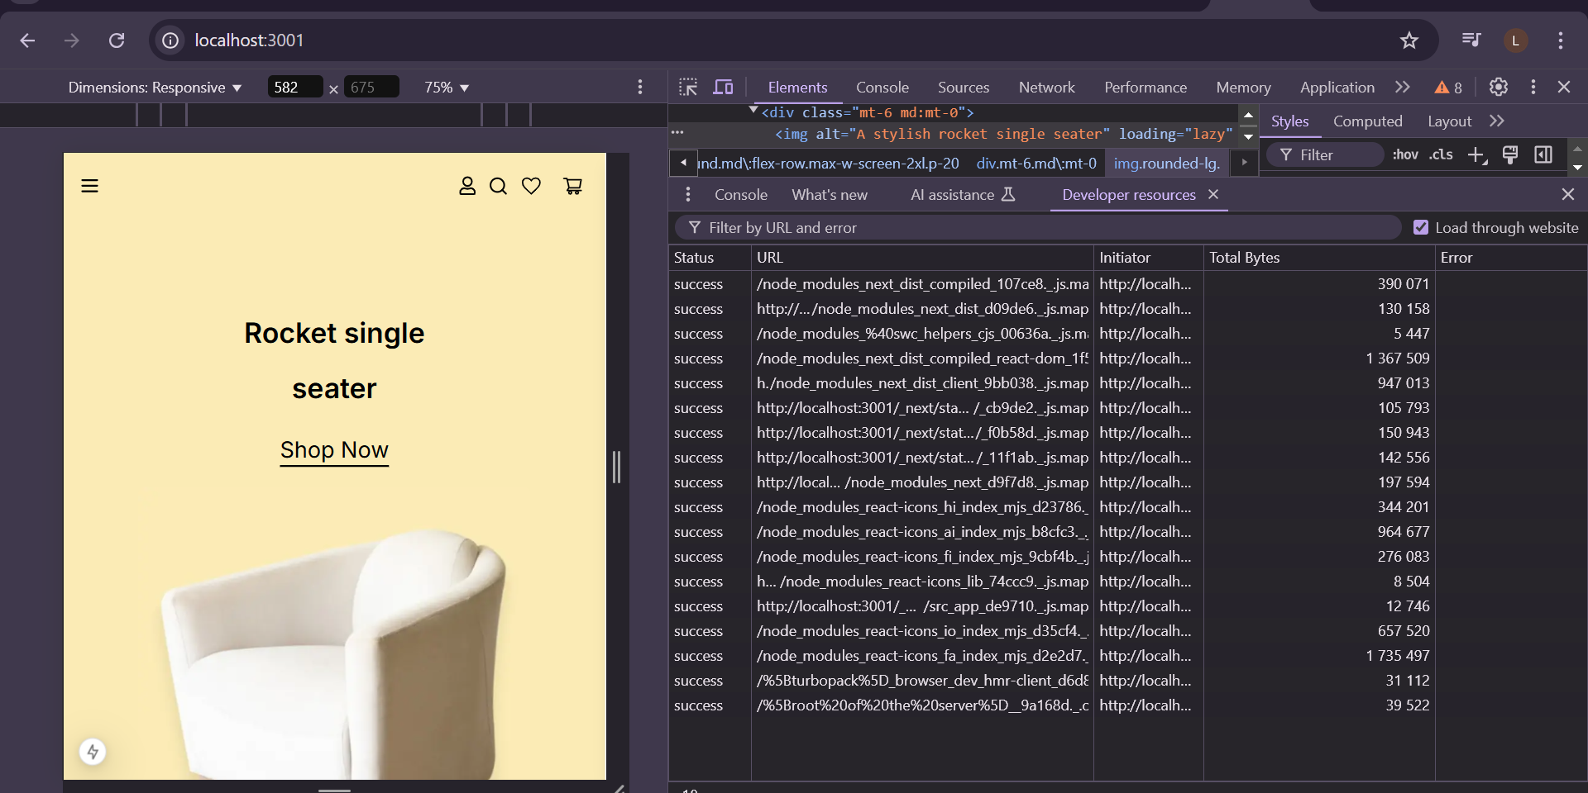

**Performance Monitor**

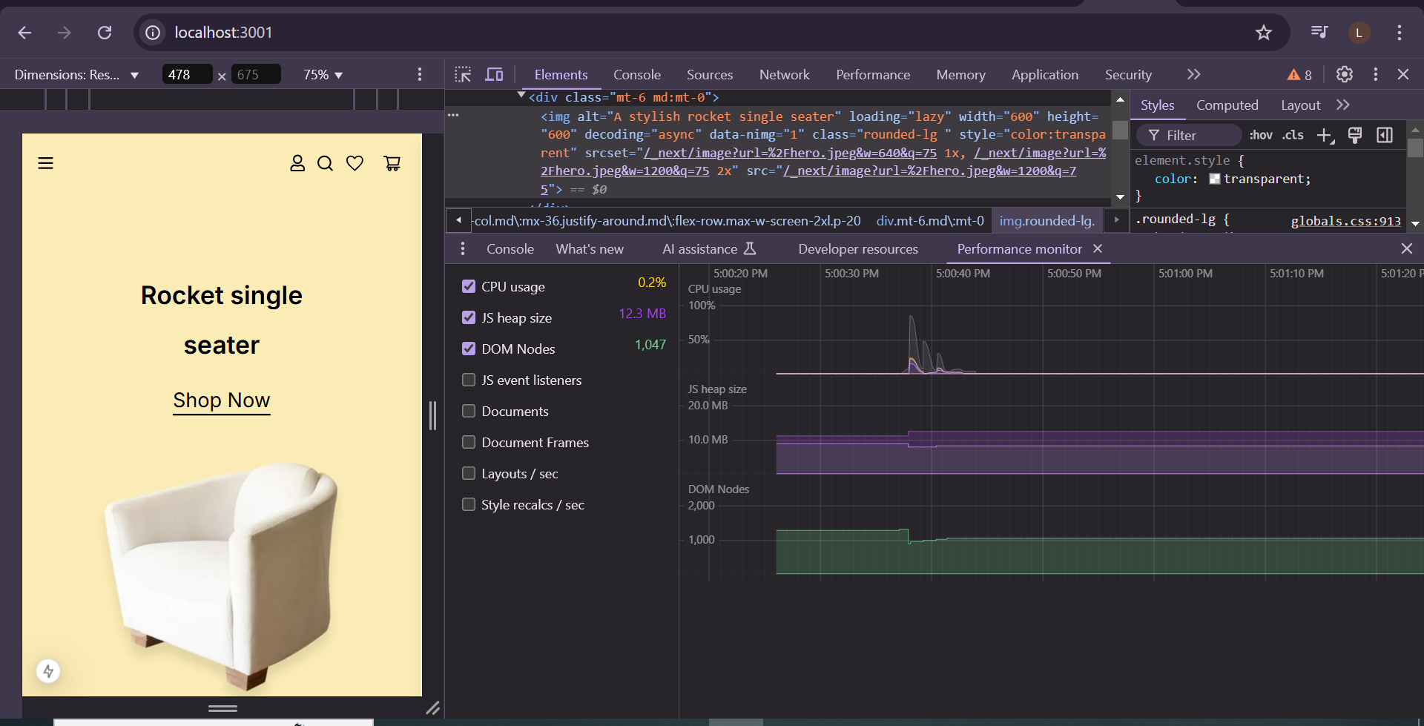

**Issues**

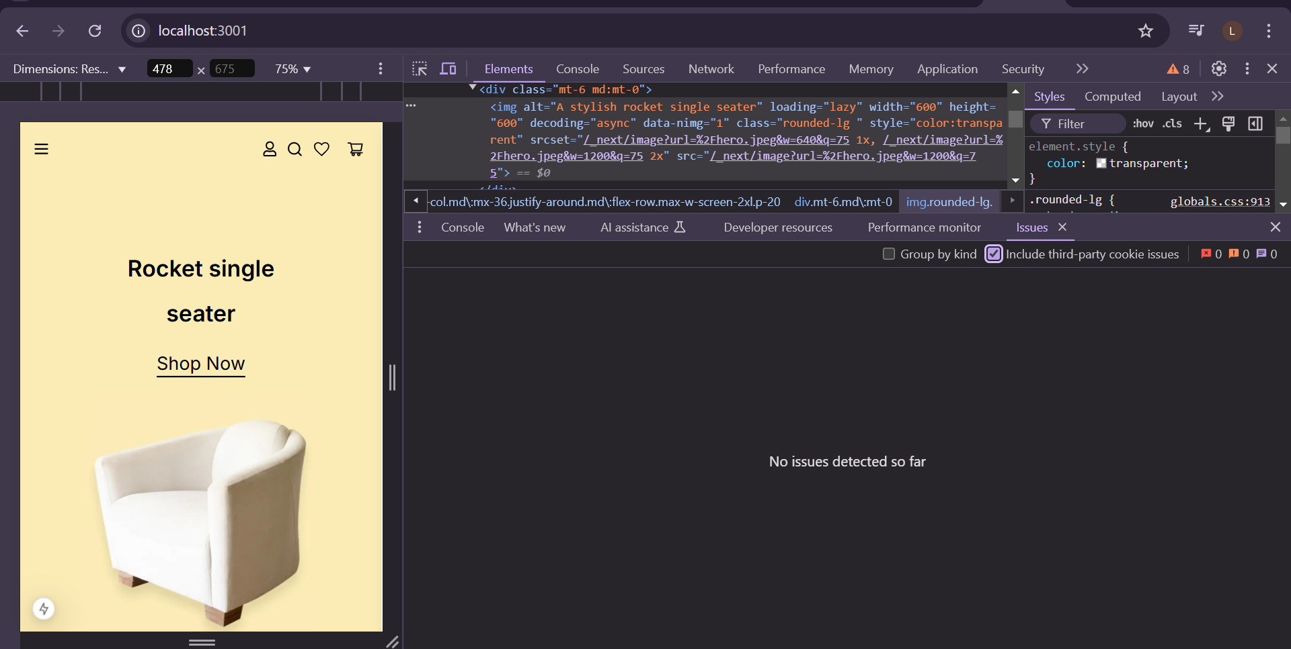

**Security**

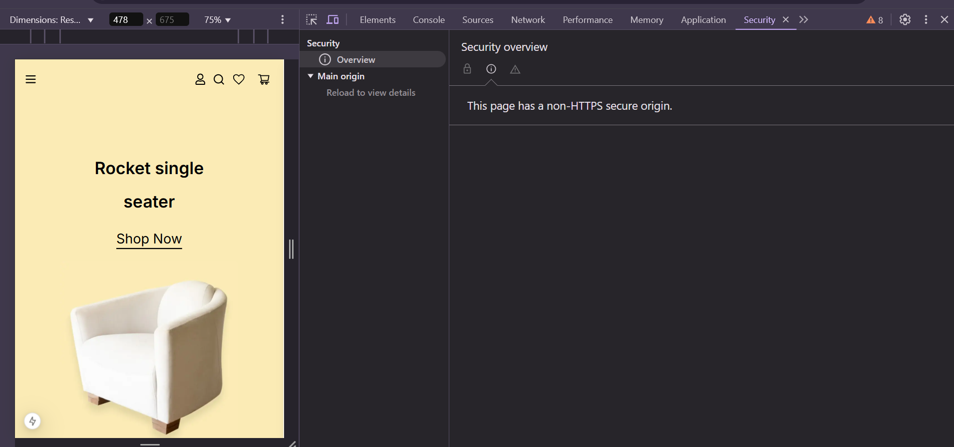

**Completed day 5**